***The 6 steps Checking out through to checking in***

Step 1. Check out the file

Step 2. Finding a name and copying details to the notes.

Step 3. Give the individual a Family Search Personal Identifier (FSPId)

Step 4. Check Temple Ordinances (optional).

Step 5. Align the data both ways using the Review Sync individual option.

Step 6. Check in the file.

The Action that takes place along the way



***Step 4.*** Check Temple Ordinances.

Users with access can check if LDS temple Ordinances have been performed (optional)

Temple File

FamilySearch

The journey begins and ends at the Collaboration Server. The records are safe and available only to the family members who are given access to them.

Family Search/Family Tree



***Step 5.*** Align the data both ways using Review Sync Individual.

With the keys of both databases the data can be synced both ways.

***Step 3.*** Give the Individual a Family Search Personal Identifier (FSPId)

AQ enables each individual to have 2 keys.

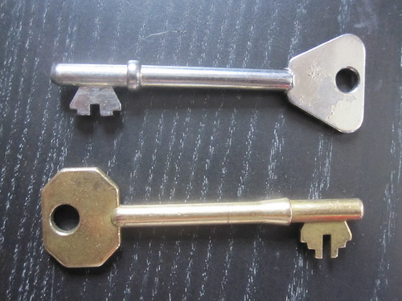

Server

Collaboration Server



***Step 6.*** Check in the File

Check In

Check Out

***Step 2.*** Finding a name and copying details to the notes.

AQ becomes a Note Pad – Finding an individual using the records available





AQAQ

***Step 1.*** Check Out. Updates can only be made by the person who has the file checked out.

AQ

Ancestry.com

WorldVitalRecords.com

British India Office marriages

Find my Past